// An example of nested try statements.
class NestTry {
public static void main(String[] args) {
try {
int a = args.length;
/* If no command-line args are present,
the following statement will generate
a divide-by-zero exception. */
int b = 42 / a;
System.out.println("a = " + a);
try { // nested try block
/* If one command-line arg is used,
then a divide-by-zero exception
will be generated by the following code. */
if(a==1) a = a/(a-a); // division by zero
/* If two command-line args are used,
then generate an out-of-bounds exception. */
if(a==2) {
int[] c = { 1 };
c[42] = 99; // generate an out-of-bounds exception
}
} catch(ArrayIndexOutOfBoundsException e) {
System.out.println("Array index out-of-bounds: " + e);
}
} catch(ArithmeticException e) {
System.out.println("Divide by 0: " + e);
}
}
}

2
// Demonstrate throw.
class ThrowDemo {
static void demoproc() {
try {
throw new NullPointerException("demo");
} catch(NullPointerException e) {
System.out.println("Caught inside demoproc.");
throw e; // rethrow the exception
}
}
public static void main(String[] args) {
try {
demoproc();
} catch(NullPointerException e) {
System.out.println("Recaught: " + e);
}
}
}

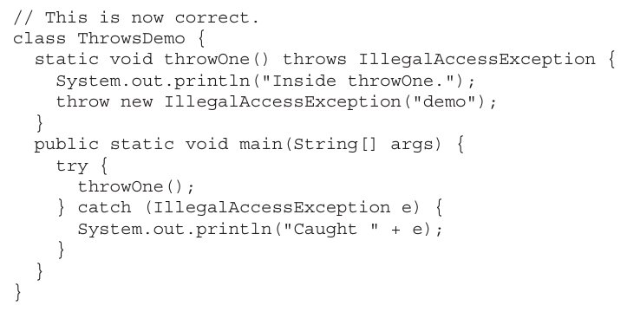

// Demonstrate finally.
class FinallyDemo {
// Throw an exception out of the method.
static void procA() {
try {
System.out.println("inside procA");
throw new RuntimeException("demo");
} finally {
System.out.println("procA's finally");
}
}
// Return from within a try block.
static void procB() {
try {
System.out.println("inside procB");
return;
} finally {
System.out.println("procB's finally");
}
}
// Execute a try block normally.
static void procC() {
try {
System.out.println("inside procC");
} finally {
System.out.println("procC's finally");
}
}
public static void main(String[] args) {
try {
procA();
} catch (Exception e) {
System.out.println("Exception caught");
}
procB();
procC();
}
}

// This program creates a custom exception type.
class MyException extends Exception {
private int detail;
MyException(int a) {
detail = a;
}
public String toString() {
return "MyException[" + detail + "]";
}
}
class ExceptionDemo {
static void compute(int a) throws MyException {
System.out.println("Called compute(" + a + ")");
if(a > 10)
throw new MyException(a);
System.out.println("Normal exit");
}
public static void main(String[] args) {
try {
compute(1);
compute(20);
} catch (MyException e) {
System.out.println("Caught " + e);
}
}
}

// Create a second thread.
class NewThread implements Runnable {
Thread t;
NewThread() {
// Create a new, second thread
t = new Thread(this, "Demo Thread");
System.out.println("Child thread: " + t);
}
// This is the entry point for the second thread.
public void run() {
try {
for(int i = 5; i > 0; i--) {
System.out.println("Child Thread: " + i);
Thread.sleep(500);
}
} catch (InterruptedException e) {
System.out.println("Child interrupted.");
}
System.out.println("Exiting child thread.");
}
}
Part I
254 PART I The Java Language
class ThreadDemo {
public static void main(String[] args) {
NewThread nt = new NewThread(); // create a new thread
nt.t.start(); // Start the thread
try {
for(int i = 5; i > 0; i--) {
System.out.println("Main Thread: " + i);
Thread.sleep(1000);
}
} catch (InterruptedException e) {
System.out.println("Main thread interrupted.");
}
System.out.println("Main thread exiting.");
}
}

// Controlling the main Thread.
class CurrentThreadDemo {
public static void main(String[] args) {
Thread t = Thread.currentThread();
System.out.println("Current thread: " + t);
// change the name of the thread
t.setName("My Thread");
System.out.println("After name change: " + t);
try {
for(int n = 5; n > 0; n--) {
System.out.println(n);
Thread.sleep(1000);
}
} catch (InterruptedException e) {
System.out.println("Main thread interrupted");
}
}
}

// Create a second thread by extending Thread
class NewThread extends Thread {
NewThread() {
// Create a new, second thread
super("Demo Thread");
System.out.println("Child thread: " + this);
}
// This is the entry point for the second thread.
public void run() {
try {
for(int i = 5; i > 0; i--) {
System.out.println("Child Thread: " + i);
Thread.sleep(500);
}
} catch (InterruptedException e) {
System.out.println("Child interrupted.");
}
System.out.println("Exiting child thread.");
}
}
class ExtendThread {
public static void main(String[] args) {
NewThread nt = new NewThread(); // create a new thread
nt.start(); // start the thread
try {
for(int i = 5; i > 0; i--) {
System.out.println("Main Thread: " + i);
Thread.sleep(1000);
}
} catch (InterruptedException e) {
System.out.println("Main thread interrupted.");
}
System.out.println("Main thread exiting.");
}
}

// Create multiple threads.
class NewThread implements Runnable {
String name; // name of thread
Thread t;
NewThread(String threadname) {
name = threadname;
t = new Thread(this, name);
System.out.println("New thread: " + t);
}
// This is the entry point for thread.
public void run() {
try {
for(int i = 5; i > 0; i--) {
System.out.println(name + ": " + i);
Thread.sleep(1000);
}
} catch (InterruptedException e) {
System.out.println(name + "Interrupted");
}
System.out.println(name + " exiting.");
}
}
Chapter 11
Multithreaded Programming
257
class MultiThreadDemo {
public static void main(String[] args) {
NewThread nt1 = new NewThread("One");
NewThread nt2 = new NewThread("Two");
NewThread nt3 = new NewThread("Three");
// Start the threads.
nt1.t.start();
nt2.t.start();
nt3.t.start();
try {
// wait for other threads to end
Thread.sleep(10000);
} catch (InterruptedException e) {
System.out.println("Main thread Interrupted");
}
System.out.println("Main thread exiting.");
}
}

// Using join() to wait for threads to finish.
class NewThread implements Runnable {
String name; // name of thread
Thread t;
NewThread(String threadname) {
name = threadname;
t = new Thread(this, name);
System.out.println("New thread: " + t);
}
// This is the entry point for thread.
public void run() {
try {
for(int i = 5; i > 0; i--) {
System.out.println(name + ": " + i);
Thread.sleep(1000);
}
} catch (InterruptedException e) {
System.out.println(name + " interrupted.");
}
System.out.println(name + " exiting.");
}
}
Chapter 11
Multithreaded Programming
259
class DemoJoin {
public static void main(String[] args) {
NewThread nt1 = new NewThread("One");
NewThread nt2 = new NewThread("Two");
NewThread nt3 = new NewThread("Three");
// Start the threads.
nt1.t.start();
nt2.t.start();
nt3.t.start();
System.out.println("Thread One is alive: "
+ nt1.t.isAlive());
System.out.println("Thread Two is alive: "
+ nt2.t.isAlive());
System.out.println("Thread Three is alive: "
+ nt3.t.isAlive());
// wait for threads to finish
try {
System.out.println("Waiting for threads to finish.");
nt1.t.join();
nt2.t.join();
nt3.t.join();
} catch (InterruptedException e) {
System.out.println("Main thread Interrupted");
}
System.out.println("Thread One is alive: "
+ nt1.t.isAlive());
System.out.println("Thread Two is alive: "
+ nt2.t.isAlive());
System.out.println("Thread Three is alive: "
+ nt3.t.isAlive());
System.out.println("Main thread exiting.");
}
}

